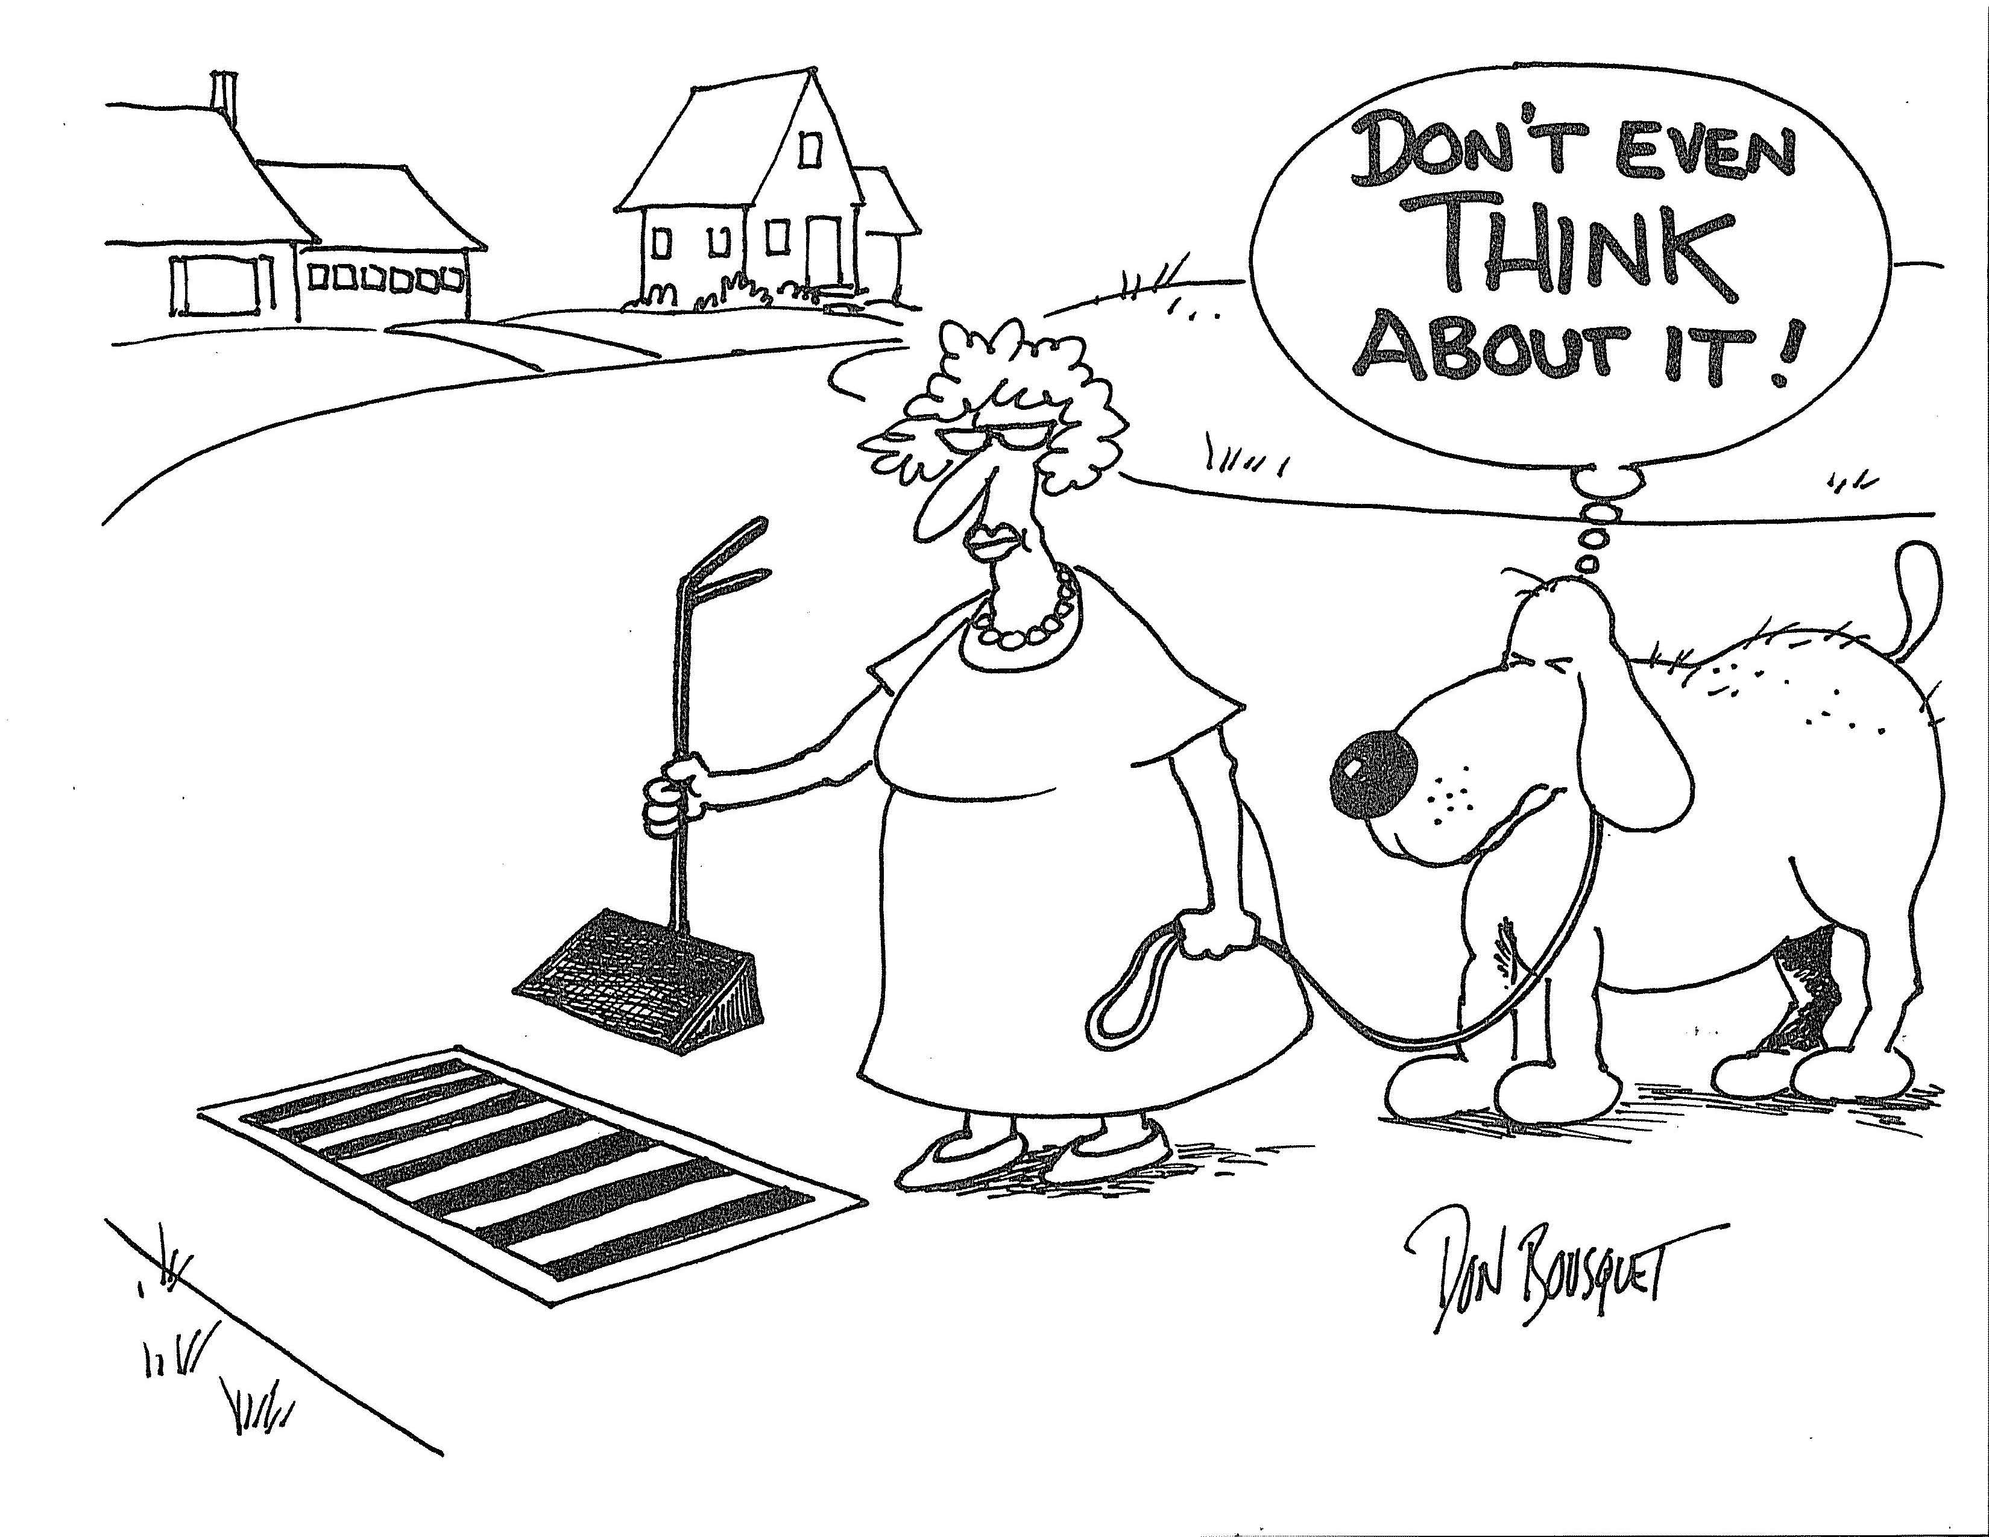

It’s no joke: Whatever enters a storm drain – and don’t blame Rover – flows directly into our local waters. Harmful bacteria from pet waste cab enter local waters and cause serious health issues. While we can’t control what geese, swans and ducks contribute, you can make a difference when it comes to house pets.

Picking up after your pet is easy, if you’re prepared:
- Carry a plastic bag with you on every walk with your dog, and you’ll have the equipment to remove your dog’s waste.
- Throw it in the nearest trash can – Never throw dog waste into a stormdrain!
- Many parks and recreational areas have courtesy bags and disposal boxes,
designed specifically for dog waste.
- Avoid letting your dog do his business within 200 feet of a water body.

For information on all things stormwater, including how you can help protect your community’s drinking water, swimming spots and overall environment, go to:
http://www.ristormwatersolutions.org

Produced by URI Cooperative Extension for RI Stormwater Solutions, a project funded by the RI Department of Transportation, in partnership with the RI Department of Environmental Management and RI municipalities

