EnviroScape® Watershed/Nonpoint Source Model Directions
Suggested Use: The model can be used with people of all ages and is recommended for grades K-12. It is suitable for use in the classroom or at festivals and can be used in the sample lesson plan laid out in this binder.
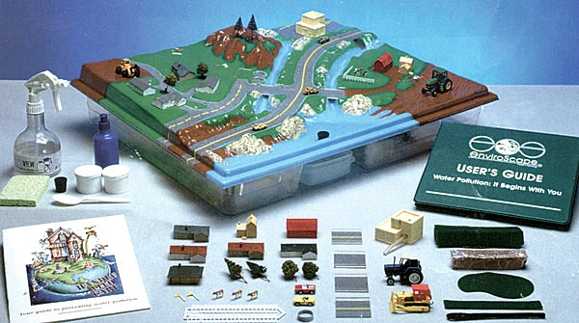
Introduction: The EnviroScapes model was recently purchased by the RI Stormwater Solutions Team to be used as a stormwater teaching tool for groups around Rhode Island. This colorful model, used by environmental educators around the country, helps students visualize the sources of stormwater, or nonpoint, pollution. Through hands-on interaction with the model students can grasp the concept of a watershed and think about ways to reduce their impact to water pollution.
Description of Model: The EnviroScape® Watershed/Nonpoint Source Model tracks pollution from point and nonpoint sources, including nonpoint sources (residential areas, stormwater, forestry areas, transportation, recreation, agriculture and construction) as well as point sources (factory, sewage treatment plant, storm drains). Stormwater pollution and runoff are visually apparent when rain falling over the landscape top carries soil (cocoa), chemicals (colored drink mixes) and oil (cocoa and water mixture) through a watershed to a body of water. Stormwater runoff and storm drain function are also addressed. Best management practices include felt buffer strips as vegetation, clay to create berms and other methods to show conservation and water pollution prevention measures at work. The model shows nonpoint source pollution and the steps everyone can take to help prevent environmental contamination. The EnviroScape Watershed/Nonpoint Source Model also teaches an overall watershed concept. Two waterways flow into a larger water body, which is representative of a lake, river, bay, or ocean. The unit comes complete with a kit containing everything you need to demonstrate the movement of water through a watershed and the pollution that runoff may cause.
Borrowing the Model: The model will be loaned out to environmental educators on a first-come first-serve basis. Groups will have the option of scheduling a time to meet with a RI Stormwater Solutions Team member to complete training on the classroom/festival use of the model. The logistics of borrowing the model will be finalized in the next month and will be featured on www.ristormwatersolutions.org under “Resources” > “Teachers and Kids.”

